H.T No
Regulations:
A19

Sreenidhi Institute of Science and Technology
(An Autonomous Institution)
Code No:7W102 Date: 12-July-2021 (FN)

M.Tech I-Year I-Semester External Examination, July - 2021 (Regular & Supplementary)
ADVANCED FINITE ELEMENT ANALYSIS (CADCAM)

Time: 3 Hours Max.Marks:70

Note: a) No additional answer sheets will be provided.
b) All sub-parts of a question must be answered at one place only, otherwise it will not be valued.
c) Missing data can be assumed suitably.

ANSWER ANY 5 OUT OF 8 QUESTIONS. EACH QUESTION CARRIES 14 MARKS.

Bloom's Cognitive Levels of Learning (BCLL)

Remember | L1 | Apply | L3 | Evaluate | L5
Understand | L2 | Analyze | L4 | Create | L6

 |  |  | BCLL | CO(s) | Marks
1. |  | Compute the Eigen values and Eigen vectors for the given function 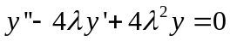, with boundary conditions are, 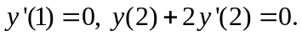 | L3 | CO1 | [14M]
2. |  | For the two-bar truss element shown in Fig(a), determine  - the displacements of node 1  - stress in element 1-3  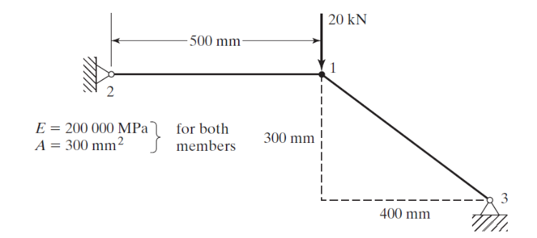  Fig(a) | L4 | CO2 | [14M]
3. |  | For the configuration shown in the fig(b), determine the following, using a one-element model.  - The deflection at the point of load application  - Comment on stress also  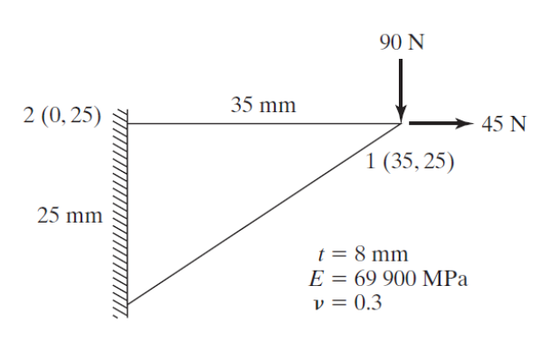  Fig(b) | L5 | CO3 | [14M]
4. |  | Determine the natural frequencies of the simply supported beam shown in fig (c), using one element model.  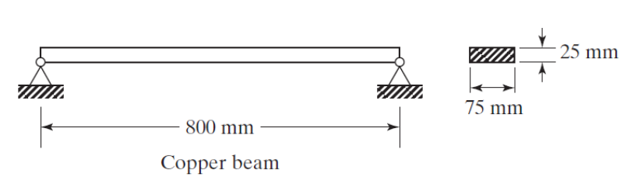  Fig (c) | L5 | CO4 | [14M]
5. |  | A composite wall consists of three materials, as shown in Fig. (d). The outer temperature is T₀=20⁰C. Convective heat transfer takes place on the inner surface of the wall with T∞=800⁰C and h=25 W/m² ⁰C. Determine the temperature distribution in the wall.  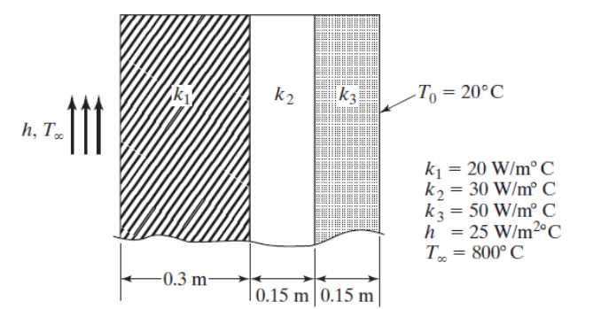  Fig. (d) | L5 | CO5 | [14M]
6. |  | Propose an expression for the velocity of the fluid in a steady laminar flow between two fixed parallel plates show in Fig (e).  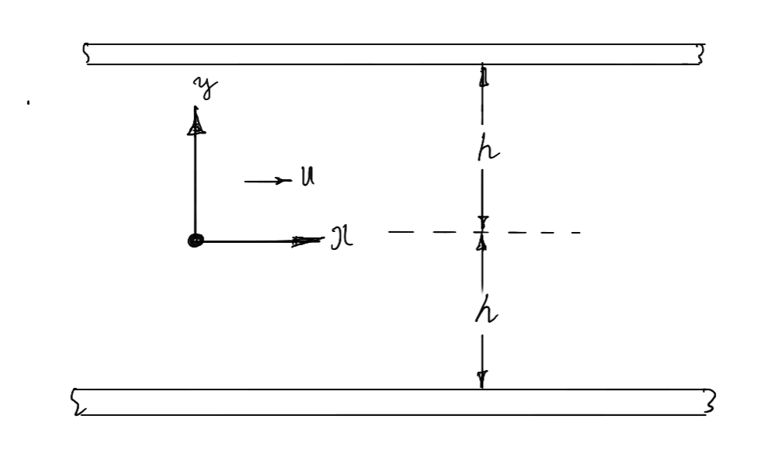  Fig(e) | L6 | CO6 | [14M]
7. | a) | Solve the equation 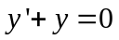using initial value problem for the boundary condition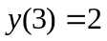. | L3 | CO1 | [5M]
 | b) | Discuss the element bending moment and shear force in beam element. | L2 | CO2 | [5M]
 | c) | Discuss the shape functions in CST. | L2 | CO3 | [4M]
8. | a) | Develop the element mass matrix for CST | L4 | CO4 | [7M]
 | b) | Prepare the temperature function for one dimensional heat conduction element. | L3 | CO5 | [7M]

-- 00 -- 00 –

